M3 SQL assignment 4.2 Rossler Gian Karlo Boquiren

Part 1

1. STORE PROCEDURE: list_animals. Display the list of all the animals with animal name and race name

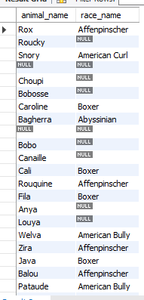

1. STORE PROCEDURE: fetch_animal_age IN: Animal id OUT: Animal age in numbers  
     
   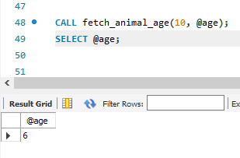
2. STORE PROCEDURE: price_of_pets IN: 3 Animal ids OUT: Price of the 3 animals (price is determined by adding species price to race price if exists).

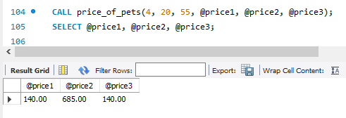

1. STORE PROCEDURE: total_age_of_animal IN: 1 Animal id INOUT: Cumulative age of the animals Do it for at least 5 animals

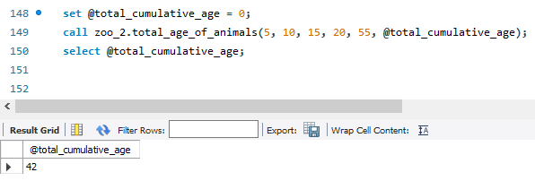

Part 2

5. STORE PROCEDURE: fetch_animal_parents

IN: animal id

Display if both parents exist -> show the parent's name (both mom and dad)

Else if only one of the parent exist -> show their name

Else show -> No parents

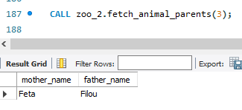

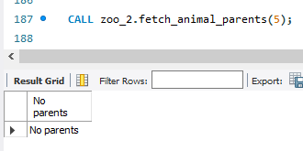

6. STORE PROCEDURE: fetch_animal_info  
IN: animal id   
Display the animal name, gender, dob, and race.  
-if animal doesn't have a name display: "No name"  
-if animal doesn't have a gender display: "To Be Decided"  
-if animal doesn't have a race display: "Unknown"

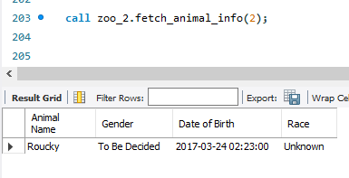

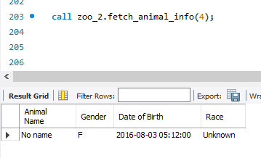

7. STORE PROCEDURE: Say_ma_name

IN: Animal id

OUT: Animal's name as much as it's age.

ex: I'm 3 -> Naz, Naz, Naz

